19.59: a) From constant cross-section area, the volume is proportional to the length, and Eq. (19.24) becomes 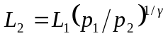and the distance the piston has moved is
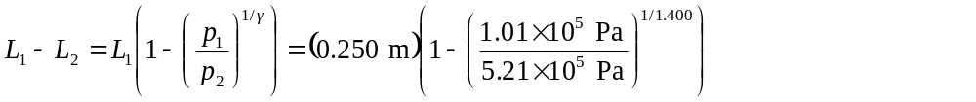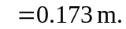
b) Raising both sides of Eq. (19.22) to the power and both sides of Eq. (19.24) to the power 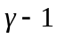, dividing to eliminate the terms 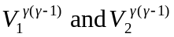and solving for the ratio of the temperatures,

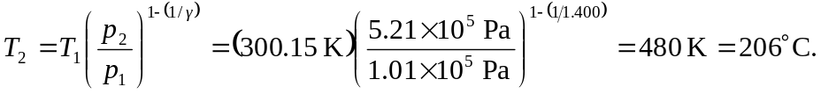

Using the result of part (a) to find 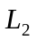and then using Eq. (19.22) gives the same result.
c) Of the many possible ways to find the work done, the most straightforward is to use the result of part (b) in Eq. (19.25),

where an extra figure was kept for the temperature difference.

